**Design Document**

Research

The following terms were used to research the capabilities of self-driving cars:

* Self-Driving Car [Zhou et al., 2019]
* Autonomous Car [Pannu et al., 2015]
* Capabilities of Self-Driving Cars [Jo et al., 2014]
* Self-Driving Car Technologies [Reddy et al., 2019]
* Energy Consumption [Phan et al., 2020]
* Predictive Maintenance [Arena et al., 2021]
* Route Planning [Zhao et al., 2018]

The first four terms provided an excellent overview of technologies commonly used in self-driving vehicles. Based on the articles read, my research focused on the three latter terms in combination with the first four to discover how these technologies work.

System Design

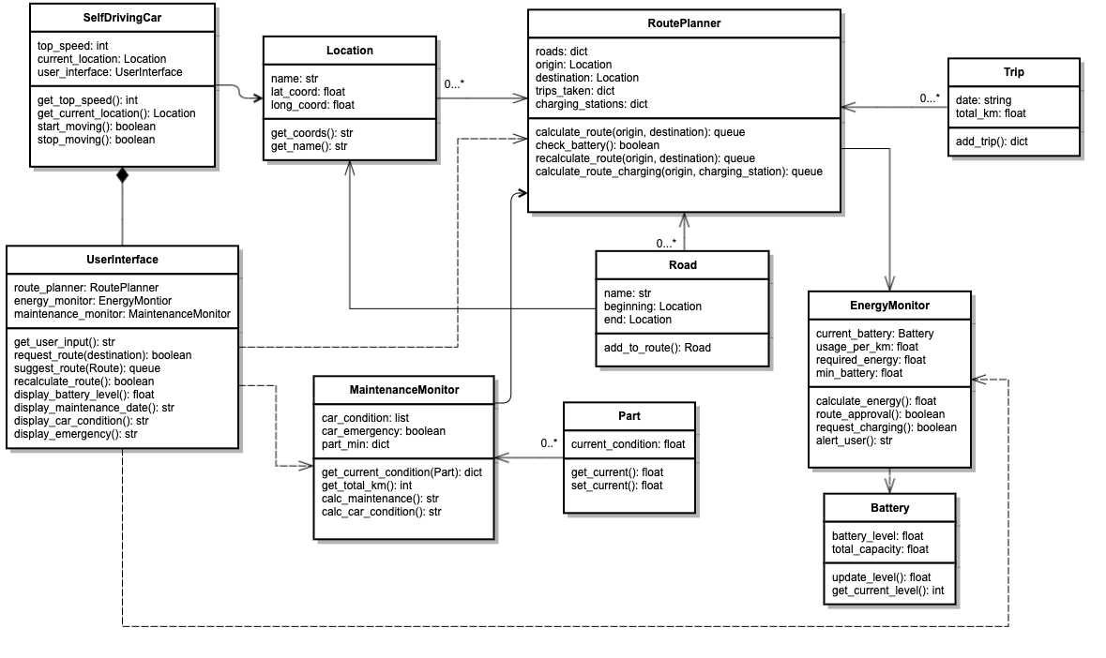

The system consists of three “main” classes, “RoutePlanner”, “EnergyMonitor”, and “MaintenanceMonitor”, which control part of the system’s operation. The “SelfDrivingCar” class represents the vehicle. The “UserInterface” class is the blueprint for the user's interface with the system. Working in conjunction with these “main” classes, the “Trip”, “Location”, “Road”, “Part”, and “Battery” classes support the inner working of the system.

The user can input a destination into the user interface, which sends the input to the “RoutePlanner”. The “RoutePlanner” calculates the optimal route from the car’s location to the destination. Once calculated, it sends the distance information to the “EnergyMonitor”, querying the battery level to ensure the car can travel along this route. If the “EnergyMonitor” approves the route, the “RoutePlanner” sends the data back to the UI, where the user can confirm the route or request a different one. If the “EnergyMonitor” calculates that the battery’s charge is insufficient, it requests a route to a charging station and informs the user.

The “MaintenanceMonitor” can request the condition of each part in the car and compare it to its respective minimum. Based on the total distance travelled since the last maintenance date and the deterioration of parts, the operation can calculate when maintenance will likely be due. The car’s overall condition and battery level will be displayed on the UI.

As a route is effectively a list of coordinates, it makes the most sense to handle it as a queue. Because a queue works with the “first in, first out” principle, removing coordinates from this list will be relatively easy once the car has passed them.

To issue instructions, the system uses boolean values. For example, the “EnergyMonitor” returns “True” if it approves a route and “False” if it rejects it. The same is done when instructing the car to move or when the “MaintenanceMonitor” alerts the UI of an emergency. “Roads” and “ChargingStations” are nested dictionaries, which consist of a “name” string, a “latitude” float and a “longitude” float. “Trips” is also a nested dictionary consisting of an “ID” string, a “date” string and a “distance_travelled” string. Some classes contain instances of other classes. For example, the “beginning” and “end” attributes of the “Road” class are instances of the “Location” class. The “UserInterface” runs instances of each of the three operations. The user only interacts with the UI, which controls all other operations “behind the scenes”.

UML Diagrams

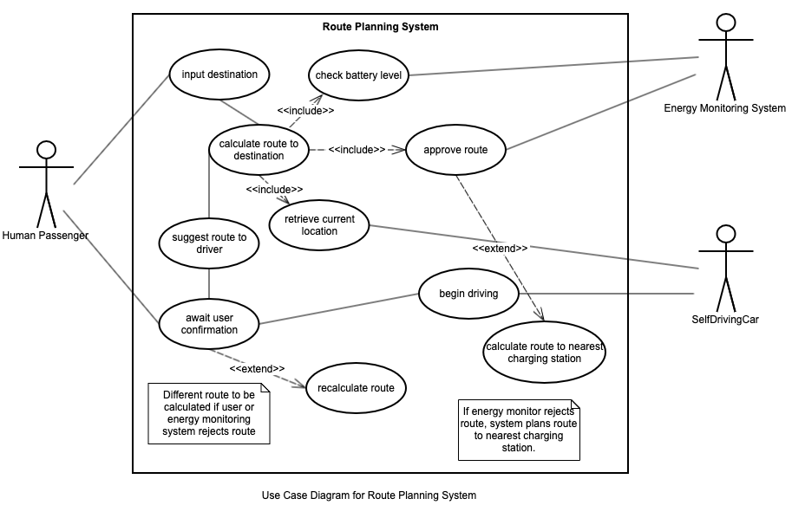

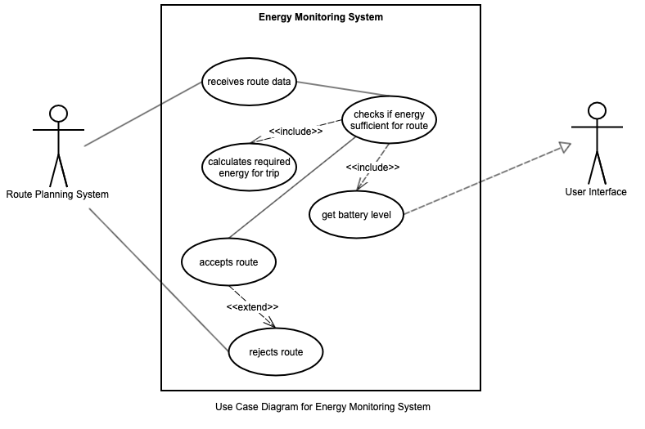

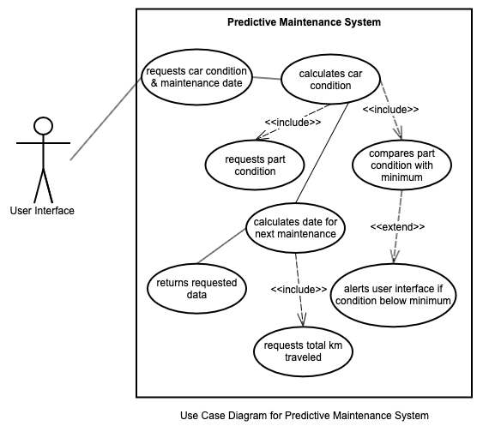

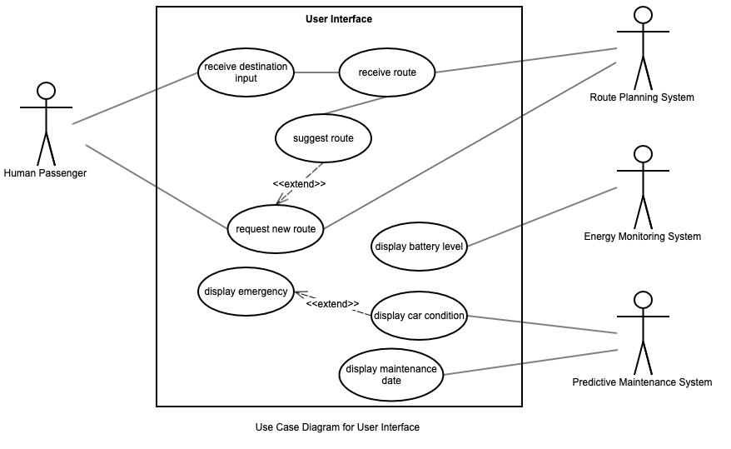

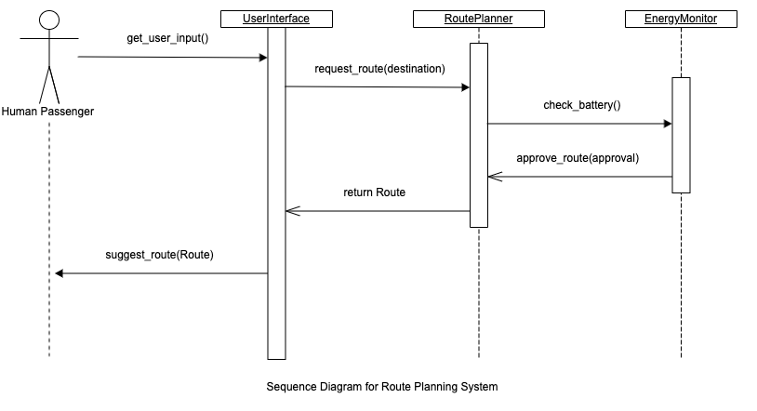

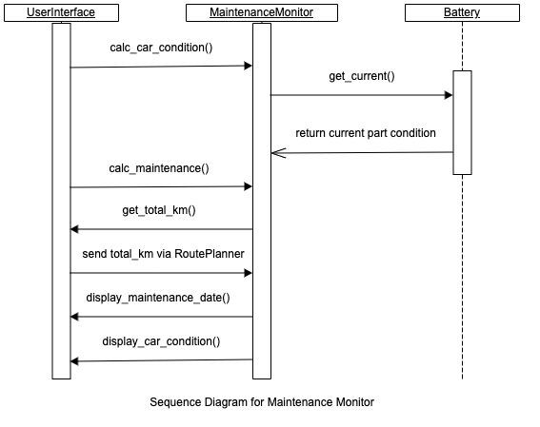

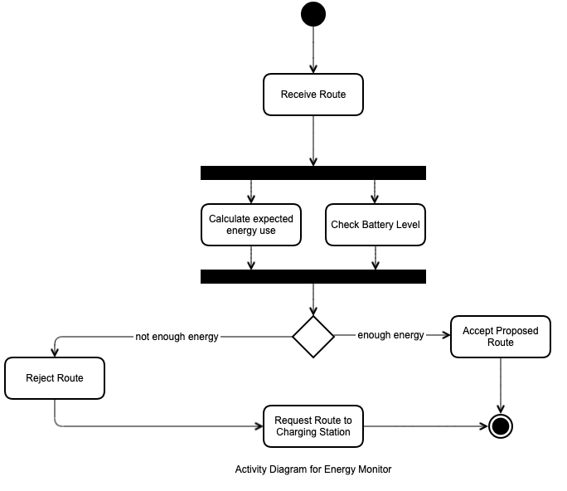

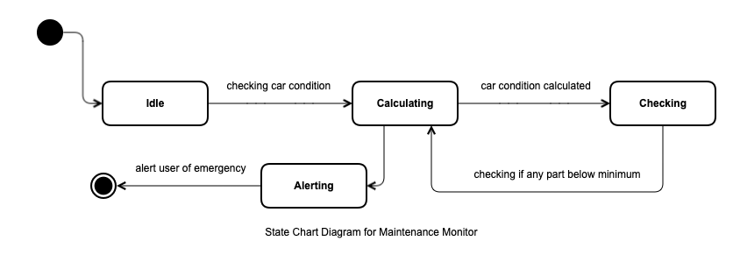

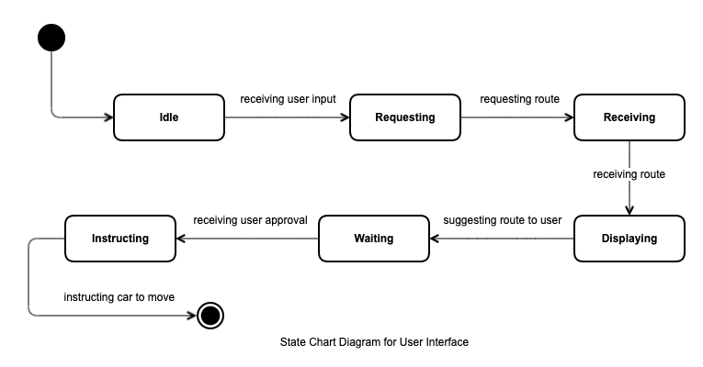

References

Reddy, P. P. (2019) Driverless Car: Software Modelling and Design using Python and TensorFlow.

Zhou, Z. Q. & Sun, L. (2019) Metamorphic testing of driverless cars. *Commun. ACM* 62(3): 61–67. DOI: <https://doi.org/10.1145/3241979>.

Zhao, J., Liang, B. & Chen, Q. (2018) The key technology toward the self-driving car. *International Journal of Intelligent Unmanned Systems* 6(1): 2-20.

Jo, K., Kim, J., Kim, D., Jang, C. & Sunwoo, M. (2014) Development of Autonomous Car - Part I: Distributed System Architecture and Development Process. *IEEE Transactions on Industrial Electronics* 61(12): 7131 - 7140.

Herr, N., Nicod, J., M., Varnier, C., Zerhouni, N. & Dersin, P. (2017) ‘Predictive maintenance of moving systems’, *Prognostics and System Health Management Conference (PHM).* Harbin, China, 9-12 July. Online: IEEE. Available from:<https://ieeexplore.ieee.org/abstract/document/8079111> [Accessed: 06/03/2023].

Phan, D., Bab-Hadishar, A., Lai, C. Y., Crawford, B., Hoseinnezhad, R., Jazar, R. N. & Khayyam, H. (2020) Intelligent energy management system for conventional autonomous vehicles. *Energy* 191. DOI:<https://doi.org/10.1016/j.energy.2019.116476>.

Arena, F., Collotta, M., Luca, L., Ruggieri, M. & Termine, F. G. (2021) Predictive Maintenance in the Automotive Sector: A Literature Review. *Mathematical and Computational Applications* 27(1): 2. DOI:<https://doi.org/10.3390/mca27010002>.